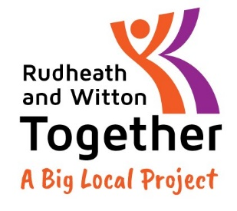
Rudheath and Witton Together –
Our Code of Conduct
As a member of the Partnership, I agree to abide by our area’s Big Local Values and all Big Local procedures.
In addition, I agree to the following values and behaviours:
- Everything we do as a partnership will be able to stand the scrutiny of the community, public, stakeholders, funders, charity regulators and the courts.
- We must behave with integrity, respect, honesty and understanding when dealing with others within the partnership as well as when dealing with the community, individuals and institutions outside it.
- The partnership will make sure we are open and honest to the community about our aims to ensure confidence from the public, stakeholders, Local Trust, Community Fund, charity regulators and government.
In particular:
- I will work together with the team to reach our goals and respect and follow the current RWT plan.
- Adhere to all agreed partnership policies and procedures.
- I will respect equality of age, disability, gender reassignment, marriage and civil partnership, pregnancy and maternity, race, religion or belief, sex and sexual orientation.
- I will not break the Law or go against charity regulations.
- I will always strive to act in the best interests of Big Local and Rudheath and Witton Together.
- I will declare any conflicts of interest or of loyalty, including gaining financially or materially, or any circumstance that might be viewed by others as such, as soon as it arises to the appropriate persons.
- When I am speaking as a member of the Partnership my comments will reflect the work of the partnership even when these do not agree with my personal views.
- When speaking as a private individual, including social media, pledge to positively promote the reputation of the partnership and those who work in it.
- I will prepare for all meetings, including reading all documents and attend all meetings, giving apologies ahead of time if unable to attend.
- I will make sure I ask if I do not understand any documents or items prior to meetings to ensure I am fully aware of the information I am voting on.
- I will engage, contribute and vote in meetings according to procedure, maintaining a respectful and supportive attitude towards others and their opinions while making my voice heard.
- I will ensure I engage with online meetings as I would in person, this includes giving enough time to the whole meeting, having the camera on (unless agreed by the group), being punctual and contributing my voice/ asking questions.
- I will accept a majority vote as decisive and final and support this decision.
- I will maintain confidentiality about discussions and agreements by the Partnership, unless authorised by the chair/ committee to speak about it. I will be mindful of this when discussing RWT information in public.
- I will participate in partnership induction, training and development activities for members.
- Should I choose to resign as a partnership member I will inform the Chair/ Deputy-Chair in writing, stating my reasons for resigning. Additionally I will participate in an exit interview.
- I understand that a substantial breach of any part of this code/ refusal to agree to this code may result in my removal as a member.

Signed:
Name:
Date:
To be read in conjunction with RWT statement on unacceptable behaviour.

